

Hackathon Submission (Level-1-Solution)

Use Case Title: AI-Powered Movie Recommendation System

Student Name: THAARANI B

Register no:410623243090

Institution: Dhaanish Ahmed College of Engineering

Department: Artificial intelligence and datascience

Date of Submission: 18.05.2025

1.Problem Statement

*In the modern digital era, film enthusiasts are bombarded with options. Streaming services have enormous collections, but viewers find it difficult to discover movies that suit their tastes.*

*Conventional recommendation algorithms tend to be based on popularity alone or simple user preferences, leading to generic recommendations that do not cater to individual viewing experiences.*



*This project seeks to build an AI-powered matchmaking system*   
*extending beyond basic content filtering. Through integrating*   
*machine learning principles and behavioral analysis, our system dynamically adjusts to users' interests, moods, and changing*   
*preferences. It aspires to build an immersive, intuitive*   
*recommendation engine that enhances entertainment experiences and promotes user engagement.*

2.Proposed Solution

*This project utilizes AI to provide highly personalized movie*

*recommendations using a refined matchmaking strategy. Through the integration of collaborative filtering, natural language processing (NLP), and sentiment analysis, we seek to enhance the*   
*recommendation process.*

*Project key components are:*   
 o *User Profile Analysis: Interpreting viewing history and*  *explicit ratings.*

o *Emotion-Based Matching: Interpreting user feedback and*  *sentiment to adapt suggestions.*

o *Hybrid Recommendation Model: Integrating content-* *based and collaborative filtering for increased accuracy.*

o *Real-Time Learning: Generating recommendations based*  *on user interactions.*



*The final system will be implemented as an interactive web application*

*using Flask or Gradio, offering a user-friendly interface that makes it*

*easily accessible.*

3.Technologies and Tools used:

Programming Languages

- Python (Primary for AI/ML, data pre-processing, and backend logic)

- JavaScript (Frontend development with React.js)

- HTML/CSS (UI structure and styling)

Machine Learning & AI Frameworks

- Scikit-learn (For collaborative/content-based filtering)

- Tensor Flow/Keras (Neural Collaborative Filtering/NCF)

- NLTK (Natural Language Processing for sentiment analysis)

- Surprise/LightFM (Hybrid recommendation models)

Data Processing & Libraries



- Pandas/Numpy (Data manipulation and feature engineering)

- Matplotlib/Seaborn (EDA visualizations)

- One-Hot/Label Encoding (Categorical data pre-processing)

- Standard Scaler (Feature normalization)

Backend & Deployment

- Flask/FastAPI (Backend API development)

- Netlify (Frontend deployment)

- Google Colab/Jupyter Notebook (Prototyping and model training)

Frontend Technologies

- React.js (Interactive UI components)

- React Icons (FaFilm, FaSearch) (UI elements)

- React Router (Navigation)

- Tailwind CSS (Styling)

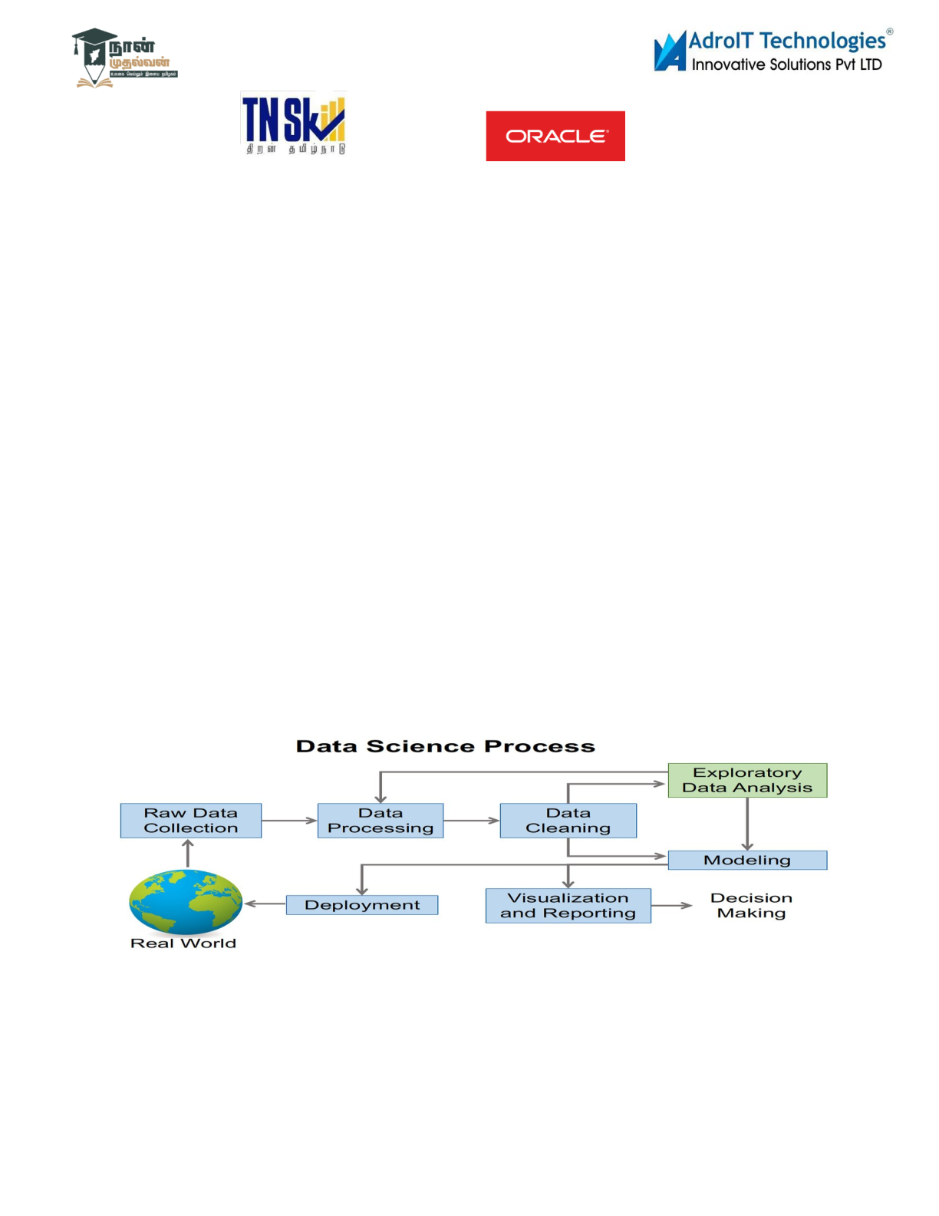

APIs & External Services

- TMDB API (Movie metadata, posters, ratings)

- IMDb API (Alternative dataset)

- User Input API (Custom sentiment/behavioral analysis)

Database & Storage

- CSV/JSON (Local dataset storage)

- Pandas DataFrames (In-memory data handling)

4. Solution Architecture & Workflow

5. Feasibility & Challenges



Feasibility: Why This Solution is Practical

Proven Technologies:

- Uses well-established tools like Python (Scikit-learn, Tensor

Flow), React.js, and Flask, which have extensive documentation

and community support.

- Hybrid recommendation models (collaborative + content-based

filtering) are a tested approach in industry (e.g., Netflix, Spotify).

Scalable Architecture:

|  |  |  |
| --- | --- | --- |
| - Modular design (data preprocessing | model training | API |

UI) allows incremental improvements.

- Cloud-ready (Netlify for frontend; could extend to AWS/GCP

for backend scaling).

Cost-Effective:



- Open-source libraries (Pandas, NLTK) and free-tier APIs (TMDB) reduce licensing costs.

- Lightweight deployment options (Flask + Netlify) suit small-to-medium datasets.

User-Centric Design:

- Interactive UI (React.js) and real-time updates (e.g., sentiment analysis) enhance engagement.

- Explainable recommendations (e.g., "Recommended because you liked Action movies") improve trust.

Challenges and Mitigation Strategies:

| Challenge | | Potential Solution |

| Data Sparsity | Use matrix factorization (SVD) or deep learning (NCF) to handle sparse user-item interactions. |

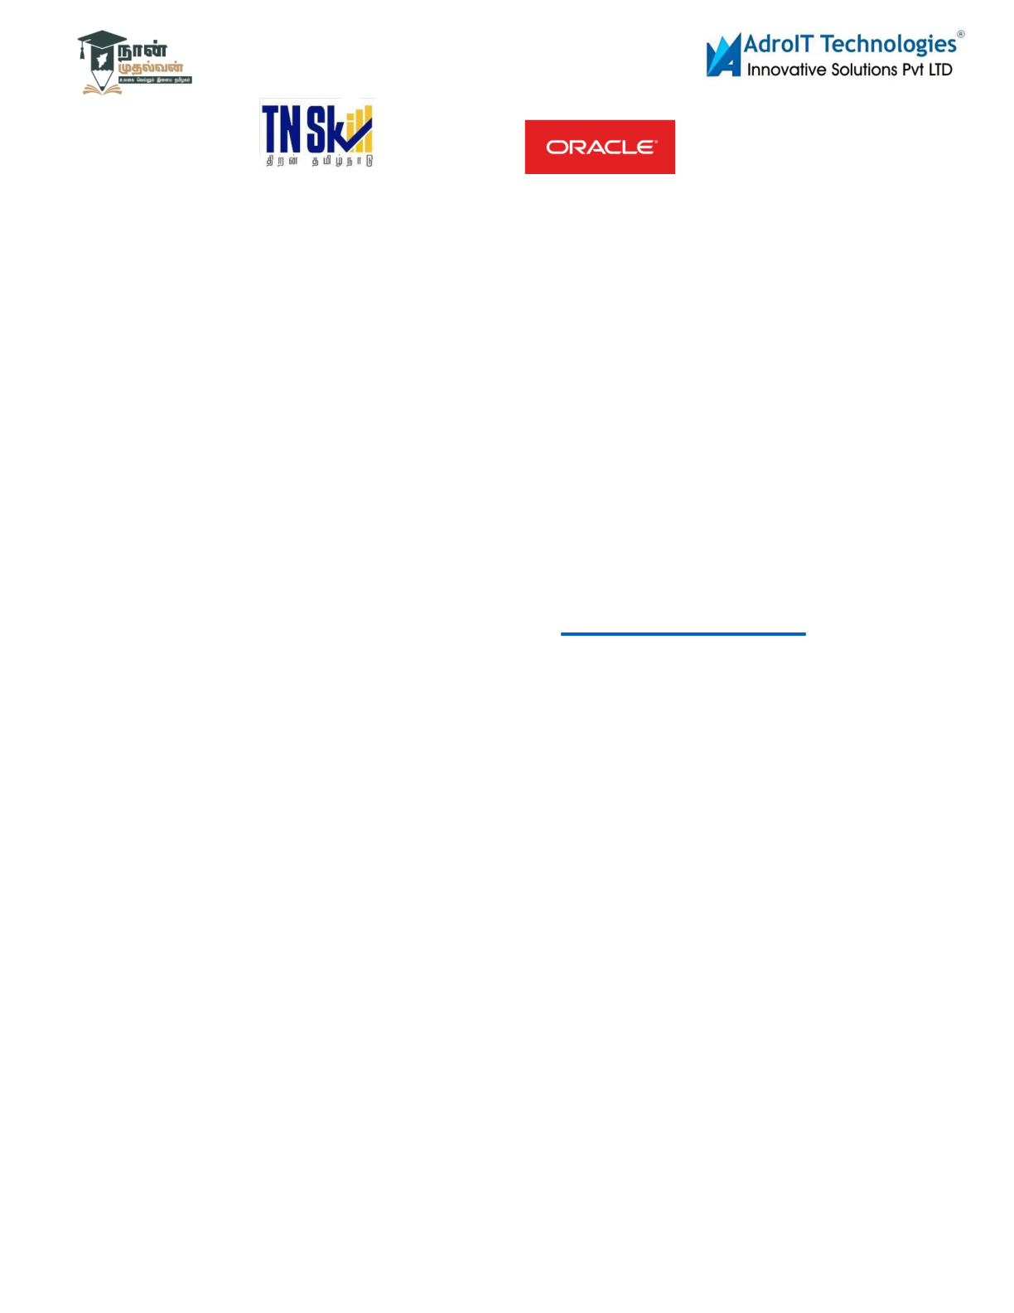

| Cold Start Problem | Hybrid models + demographic/popularity-

based fallbacks for new users/items. |

| Scalability | Migrate to distributed systems (Apache Spark)

or cloud ML (AWS SageMaker) for large datasets. |

| Bias in Recommendations | Regularize models to avoid

overfitting to popular items; diversify outputs with serendipity

scores. |

6.Expected Outcome & Impact :<https://movielisttech.netlify.app/>

AI Movie Recommender: Key Benefits

For Users:

✔ Saves time – No more endless scrolling.

✔ Personalized picks – Matches your taste and mood.

✔ discovers hidden gems – Beyond just popular films.

For Streaming Platforms:



✔ Boosts engagement – Users watch more.

✔Reduces churn – Keeps subscribers happy.

✔Data-driven insights – Better content decisions.

For Studios & Advertisers:

✔ Targets the right audience – Higher ROI on films/ads.

Why it’s better?

🔹Learns your habits (unlike static "Top 10" lists).

🔹 Explains why a movie was suggested (e.g., "Because you liked

*Inception*").

🔹 Improves over time with AI.

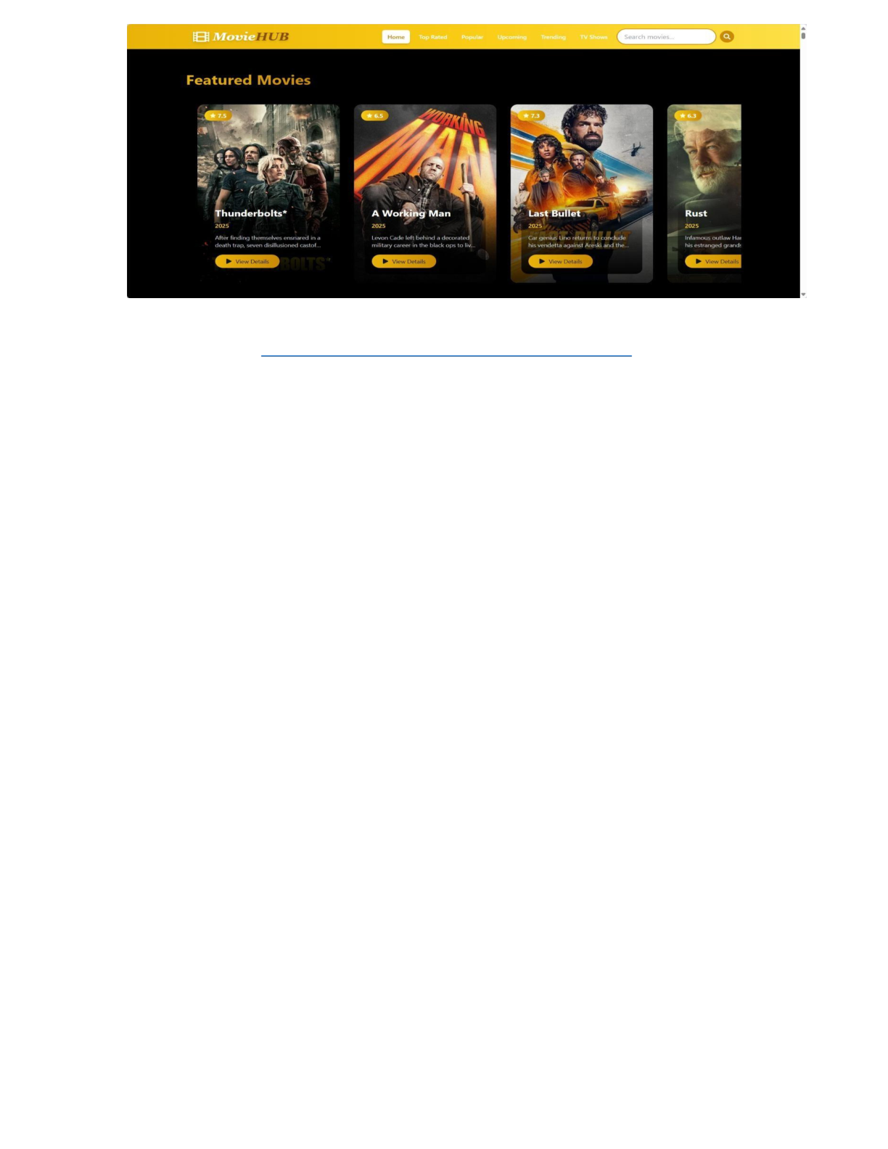

Source code: movie recommendations/index 1.html

Git hub:[https://github.com/pavankumar26dev/movierecommendations.git](https://github.com/devadace/movie-recommendation-system.git)

Win-Win: Users enjoy films faster; platforms grow revenue. 🚀

7.Future Enhancements

Future Enhancements for the AI Movie Recommendation System

1. Advanced Personalization

- Mood & Context Detection

- Use voice/tone analysis (from reviews) or time-of-day patterns to

suggest films (e.g., "Light comedies after 9 PM").

- Group Recommendations



- Suggest movies for friends/family by blending preferences (e.g., "80%

match for you, 60% for your partner").

2. Enhanced Interactivity

- "Tinder for Movies" Swipe Feature

- Like/dislike trailers or posters to refine recommendations in real

time.

- AI Chatbot

- Conversational interface ("Suggest a thriller with a twist ending").

3. Deeper Integration

- Cross-Platform Sync

- Pull watch history from Netflix/Disney+ to unify recommendations.

- Offline Mode

- Cache suggestions for users with poor connectivity.



4. Transparency & Control

- "Why This Recommendation?" Dashboard

- Show key factors (e.g., "You liked *Inception*, and 90% of fans

enjoyed *Tenet*").

- Manual Preference Tweaks

- Sliders to adjust genre/decade/actor weightings.

5. Ethical AI

- Bias Audits

- Flag/balance over-recommendation of certain genres/demographics.

- Kid-Safe Mode

- Auto-filter inappropriate content for family accounts.



Low-Hanging Fruit: Start with swipe-based feedback and manual preference sliders.

Ambitious Add-Ons: Cross-platform sync and mood detection.